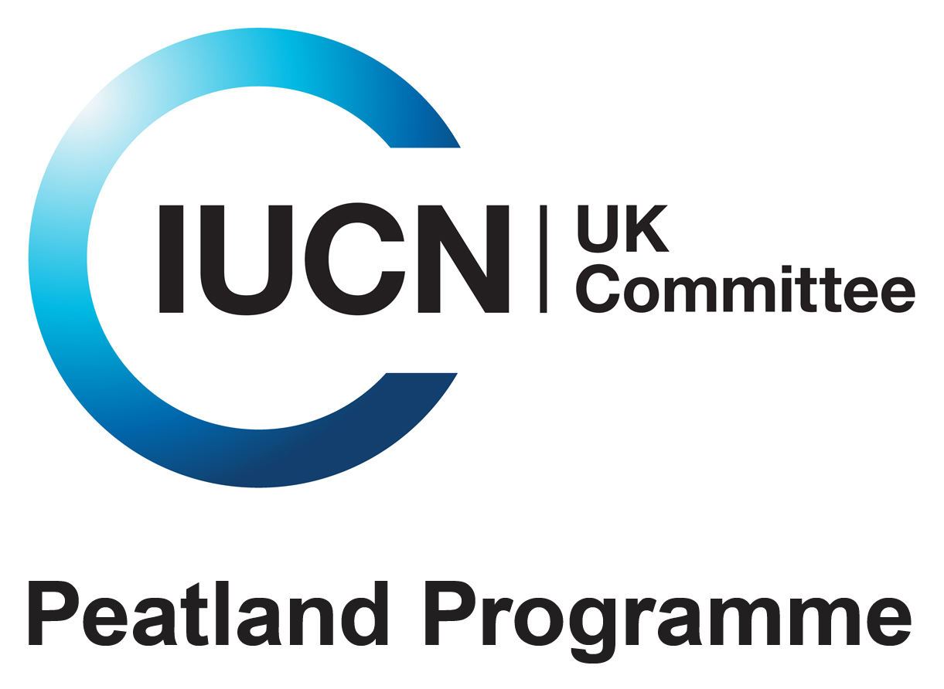

Commission of Inquiry on Peatlands
Open Consultation Response Form

23rd August 2010
The IUCN UK Peatland Programme’s Commission of Inquiry into Peatland Restoration invites interested organizations and individuals to respond to draft Scientific Reviews of eight priority topics.

Responses should be emailed to the Inquiry team at consultation@iucn.org.uk as soon as possible and no later than Monday 20th September 2010.

Issues for Consideration
Respondents are encouraged to consider the Reviews and to respond on any of the topics of interest as well as giving general comments. Reviews are available as downloads at http://iucn-uk-peatlandprogramme.org/commission/ReviewTopics.

We are particularly interested to hear your views on the following:
- Has the key scientific literature been adequately covered or is there any additional material you think may be relevant?
- Has the scientific literature been correctly interpreted?
- Are the findings of relevance to your interests in peatlands?

Please pick the review you would like to respond to and place your comments in the relevant review topic boxes. You may choose to comment on one or several reviews (max 4 pages per review), but please separate comments for each review, as we will collate comments for each review separately for consideration by the authors. Please place any general comments in the comments box at the end.

Open Inquiry
The Commission of Inquiry will also examine wider issues of relevance to policy and land management practice and therefore is keen to receive general views on the priorities for delivering peatland restoration.

An Open Inquiry event is to be held at the University of Edinburgh on 3rd November 2010 which will take oral evidence based on these submissions. Please let us know whether you would be interested to give evidence at the Open Inquiry.

IUCN UK Peatland Programme Conference
Following the production of the Draft Reviews there will be workshops on each of the topics at the IUCN UK Peatland Programme Conference, ‘Investing in Peatlands – the Climate Challenge’, on 28/29th September 2010 in Durham. For more information visit
http://iucn-uk-peatlandprogramme.org/conference2010.

Name:
Organisation:
Address:
Email:
Please indicate whether you are responding as an individual or on behalf of a group or organisation.
1 Towards an assessment of the state of UK peatlands (Report prepared by LCN and JNCC staff for the Commission of Inquiry)

2 Climate change mitigation and adaptation potential (building on JNCC GHG and C fluxes report (in press))

3 Peatland biodiversity co-funded by Macaulay Land Use Research Institute

4 Impacts of peatland restoration

5 Impacts of burning management on peatlands

6 Peatland hydrology funded by North Pennines AONB Partnership

7 Importance of peatlands for the historic environment funded by English Heritage

8 Policy measures for sustainable management co-funded by the Rural Economy and Land Use Programme (RELU)

General Comments
Are there any wider general issues you would like to raise that you believe could help deliver peatland restoration?

...

...
Would you be interested to provide oral evidence at the Open Inquiry event? yes/no

Responding to the Consultation
This is a public consultation and we would like to encourage you to draw it to the attention of others who may wish to respond.

All responses submitted become the property of the Commission of Inquiry and may be printed and published. Respondents may publish their own evidence but in so doing should indicate that it was prepared for the Inquiry.

Responses should be submitted:

By email to consultation@iucn.org.uk (preferred to facilitate analysis)

By post to Commission of Inquiry on Peatlands
IUCN UK Peatland Programme
c/o Cramond House
3 Kirk Cramond
Edinburgh EH4 6HZ

Thank you very much for offering your time and expertise!

